**Day 5.**

**Testing and Backend Refinement - [Sofa-Market]**

**Functional Deliverables:**

### *Functional Testing of Furniture Market*

Functional testing of a furniture market ensures all features work correctly, including user authentication, product management, search and filters, cart and checkout, order management, responsiveness, notifications, security, and third-party integrations, ensuring a seamless user experience.

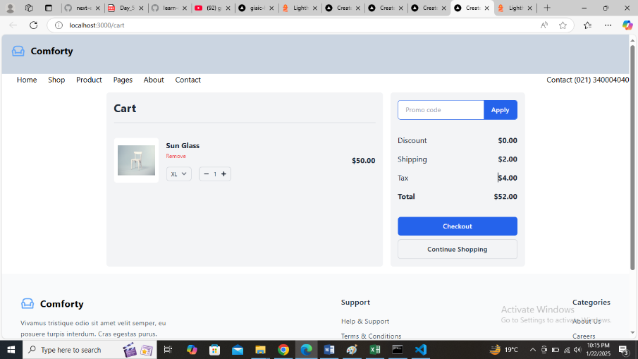

**Responsiveness:**

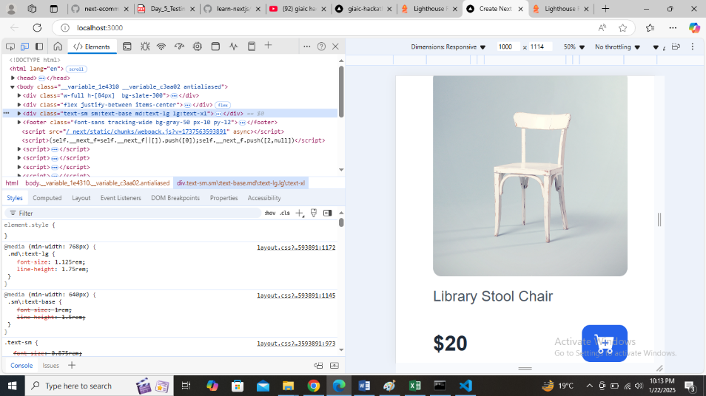

**Product API**

***Product API Status***

The **Product API** is a critical component of any e-commerce or product-based application. Its status determines the accessibility and functionality of the application.

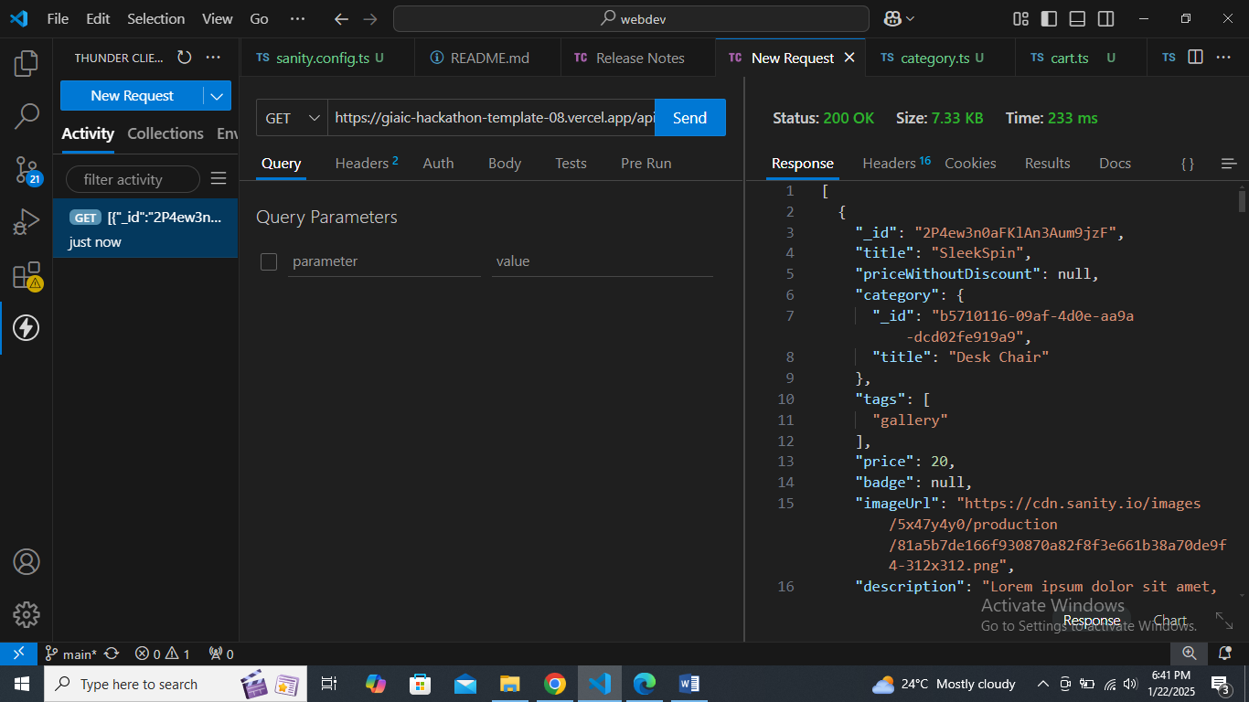

**Category API**

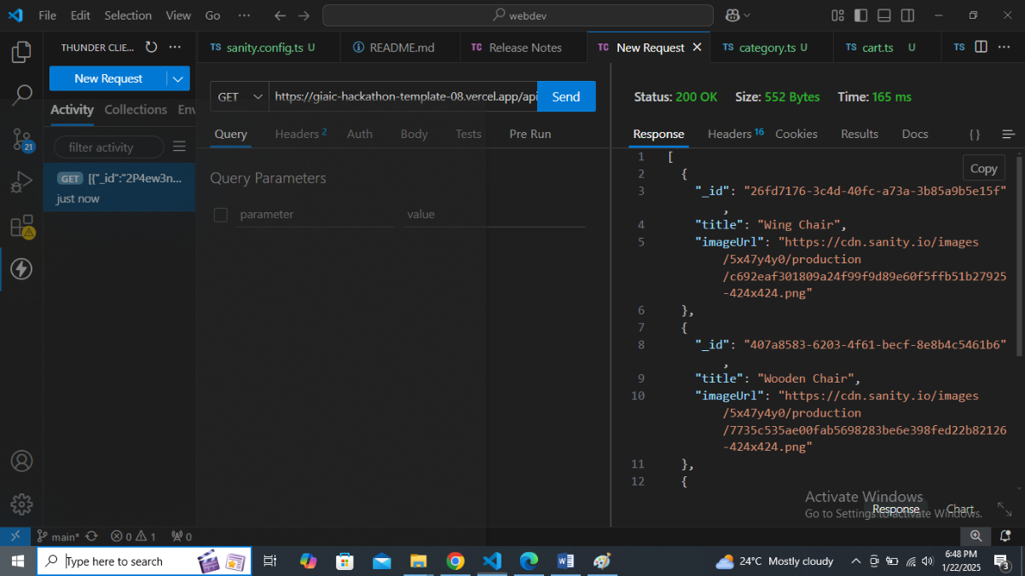

|  |  |  |  |  |  |  |  |  |
| --- | --- | --- | --- | --- | --- | --- | --- | --- |
| **Test Case ID** | **Test Case Description** | **Test Steps** | **Expected Result** | **Actual Result** | **Status** | **Severity Level** | **Assigned To** | **Remarks** |
| TC001 | Validate product listing page | Open product page > Verify products | Products displayed correctly | Products displayed correctly | Passed | high | - | No issues found |
| TC002 | Test API error handling | Disconnect API > Refresh page | Show fallback UI with error message | Error message shown | Passed | Medium | - | Handled gracefully |
| TC003 | Check cart functionality | Add product to cart > Verify cart contents | Cart updates with added product | Cart updates as expected | Passed | low | - | Issue found |
| TC004 | Ensure responsiveness on mobile | Resize browser window > Check layout | Layout adjusts properly to screen size | Responsive layout working as intended | Passed | Medium | - | Test successful |
|  |  |  |  |  |  |  |  |  |

***Performance Optimization(lighthouse):***

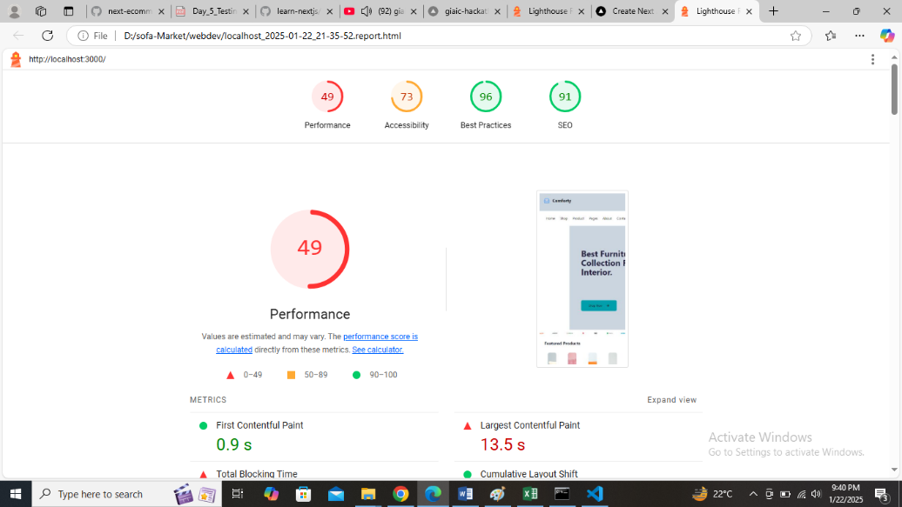

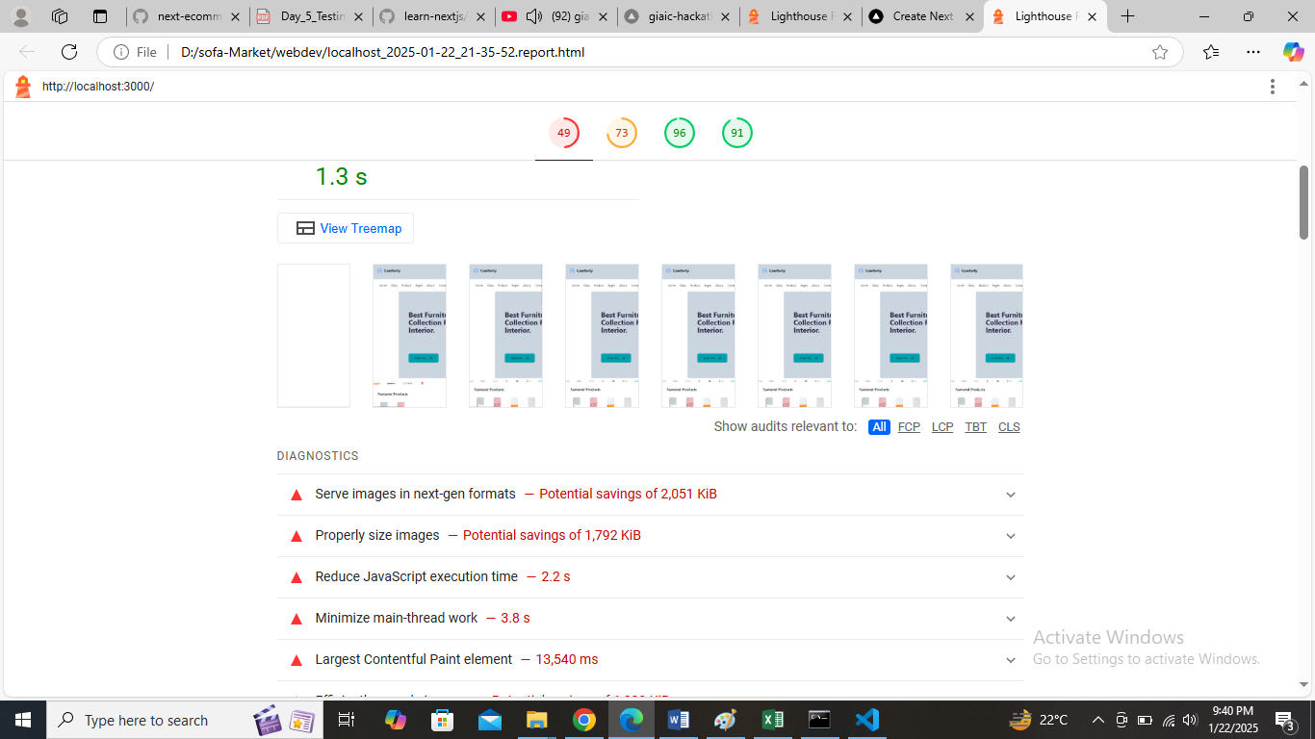

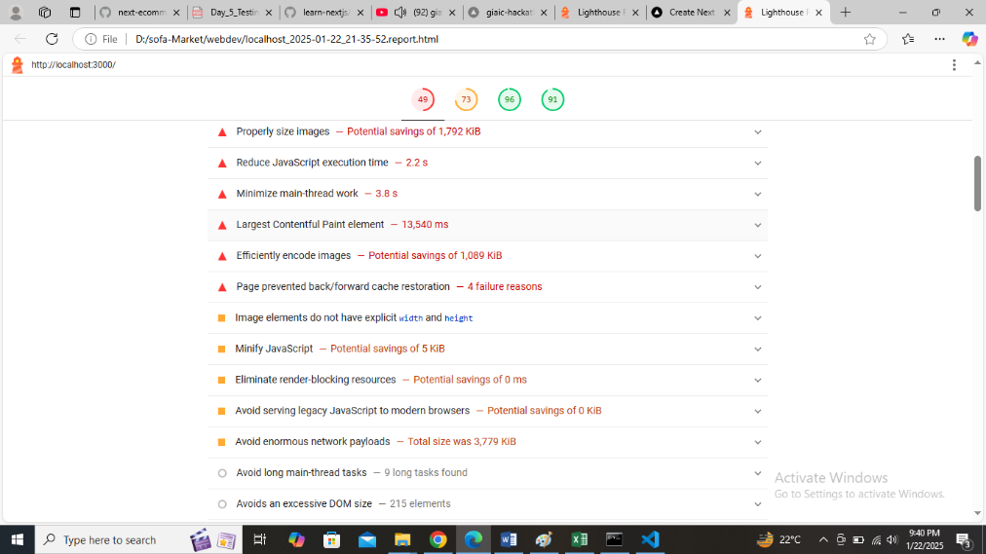

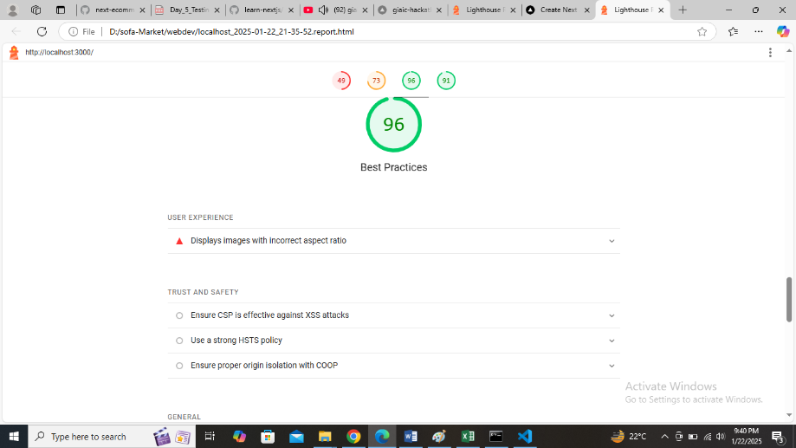

***Trust and Safety:***

Ensure CSP is effective against X SS Attacks

Use a strong HSTS policy

Ensure proper origin Isolation with COOP

***Optimization Monitor:***

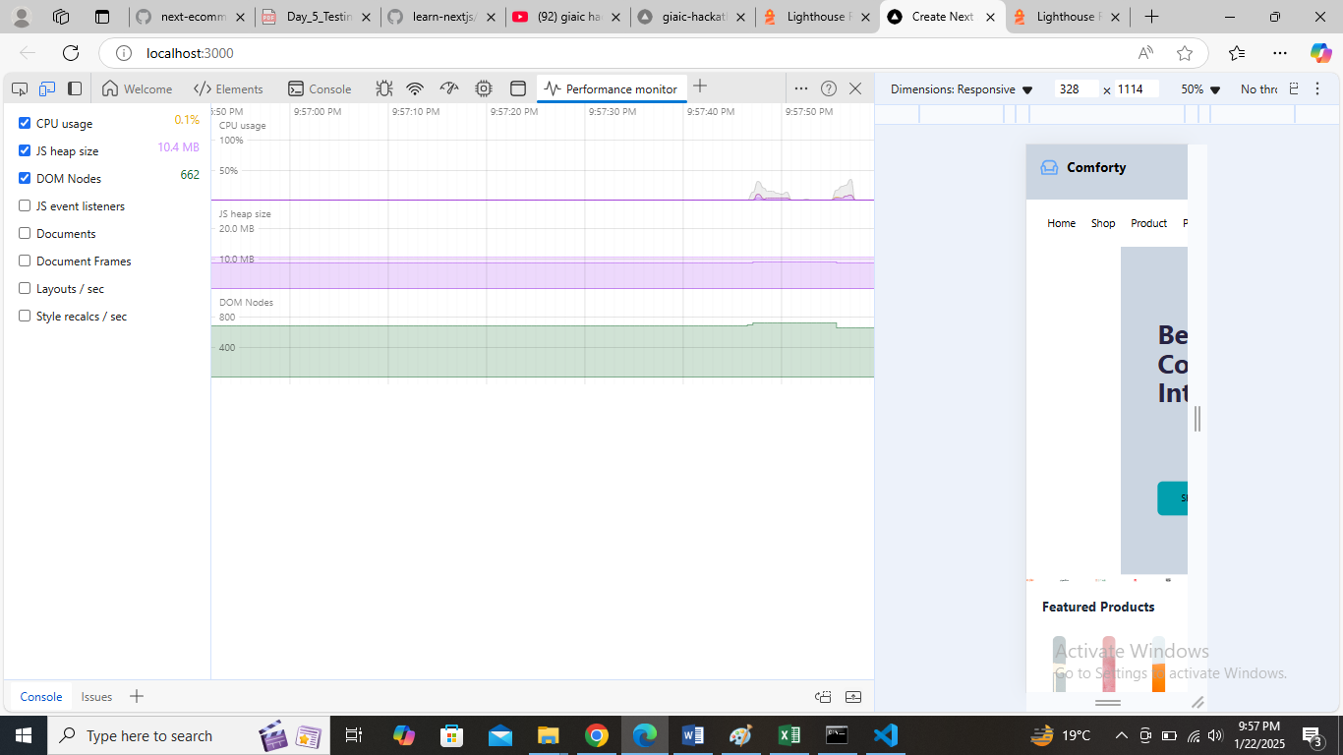

**Security:**

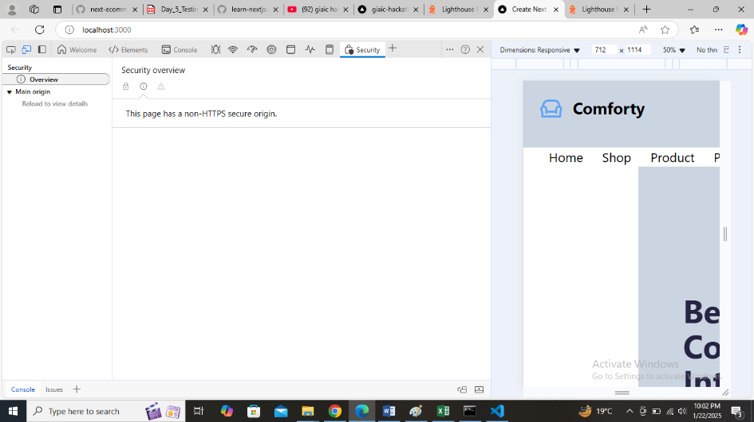

***Checklist for Day 5:***

Functional Testing:

• ✔

Error Handling:

• ✔

Performance Optimization:

• ✔

Cross-Browser and Device Testing:

• ✔

Security Testing:

• ✔

Documentation:

• ✔

Final Review:

• ✔